Create a Maven Project

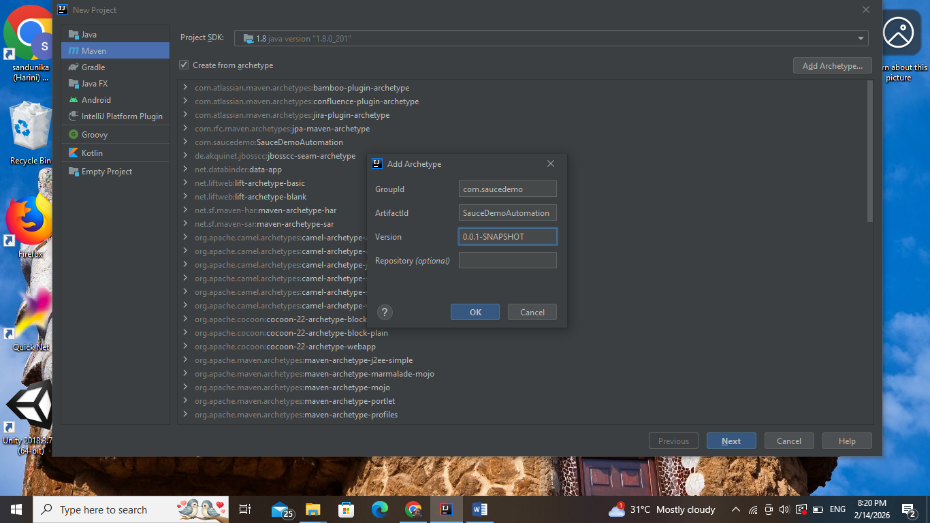

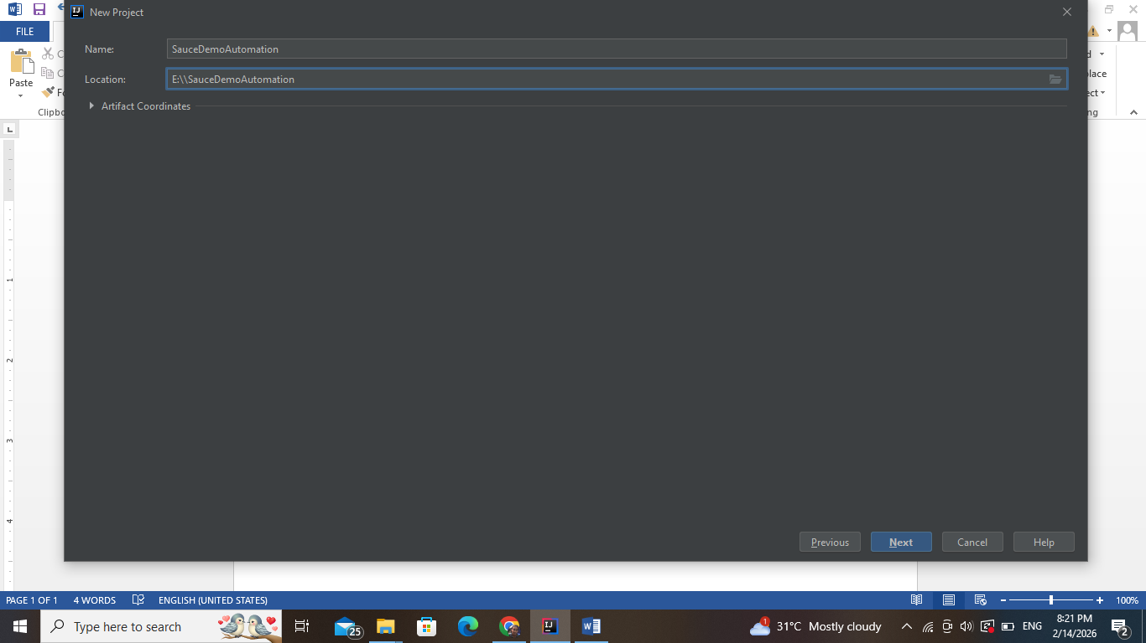

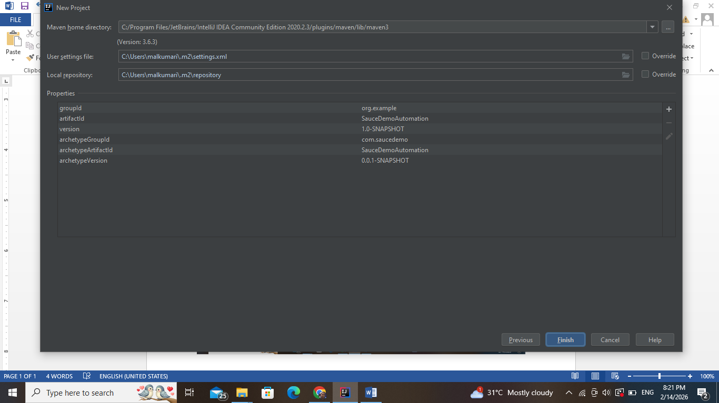

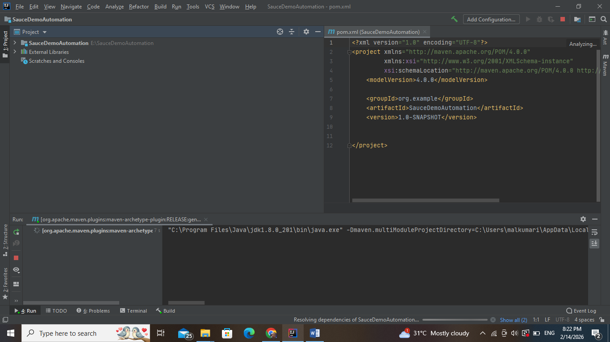

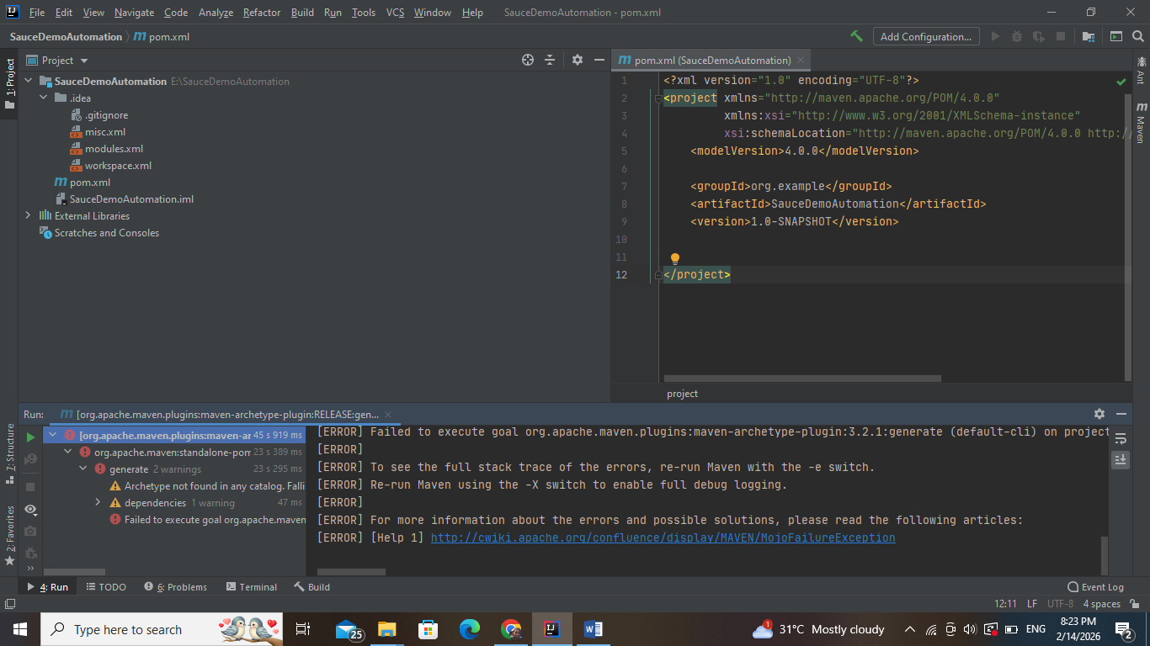

Update pom.xml

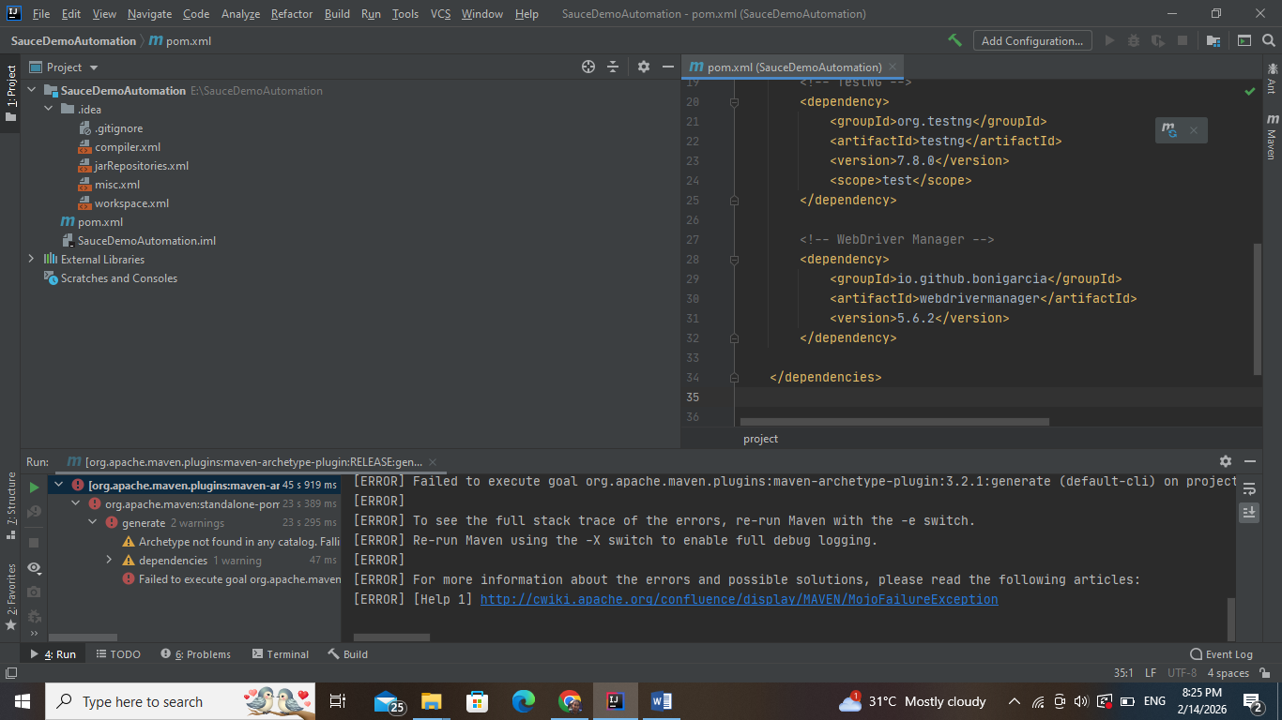

<dependencies>

<!-- Selenium -->

<dependency>

<groupId>org.seleniumhq.selenium</groupId>

<artifactId>selenium-java</artifactId>

<version>4.16.1</version>

</dependency>

<!-- TestNG -->

<dependency>

<groupId>org.testng</groupId>

<artifactId>testng</artifactId>

<version>7.8.0</version>

<scope>test</scope>

</dependency>

<!-- WebDriver Manager -->

<dependency>

<groupId>io.github.bonigarcia</groupId>

<artifactId>webdrivermanager</artifactId>

<version>5.6.2</version>

</dependency>

</dependencies>

Create Git Branch

git checkout -b CaseStudy_Intermediate

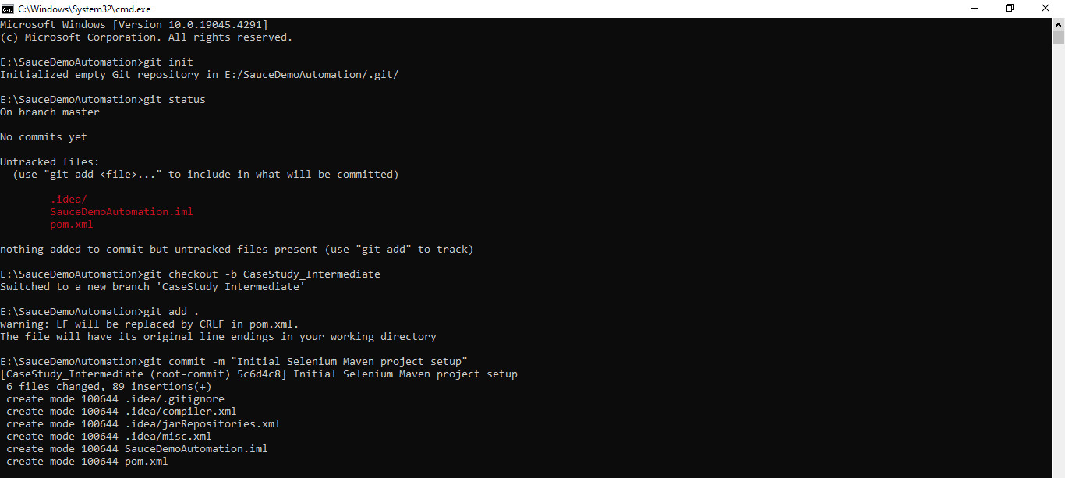

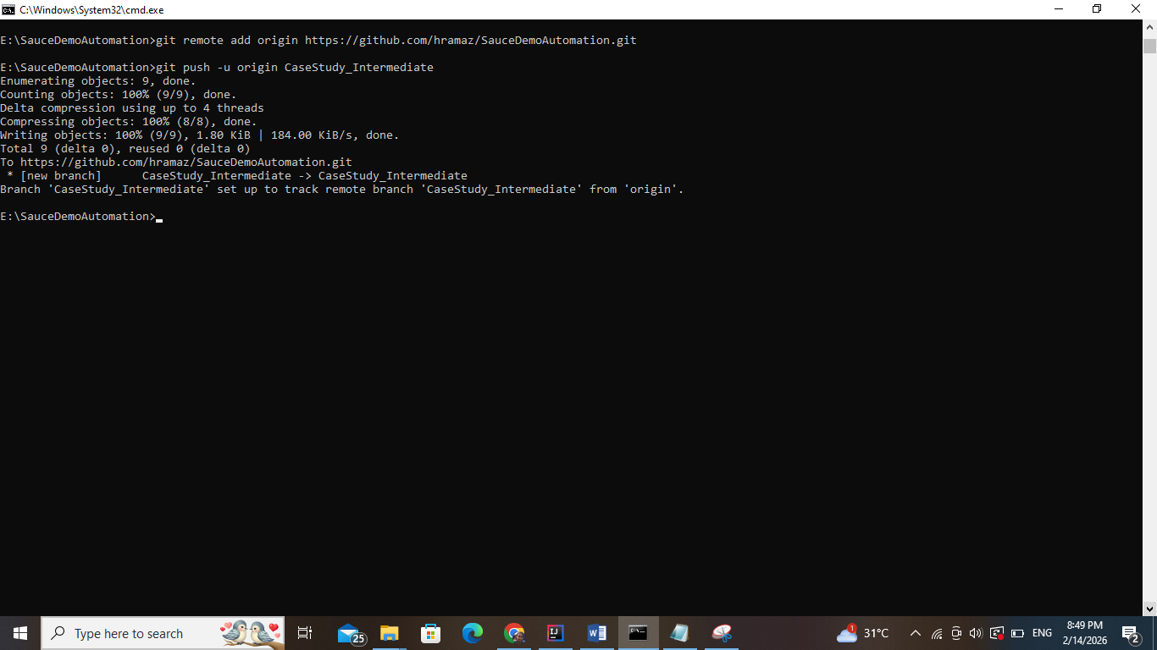

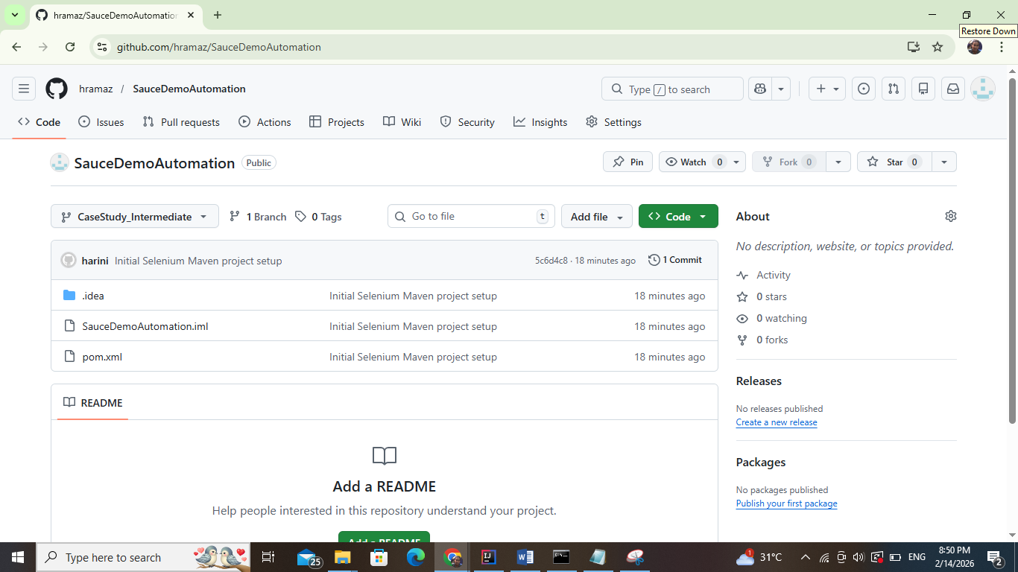

Project Structure

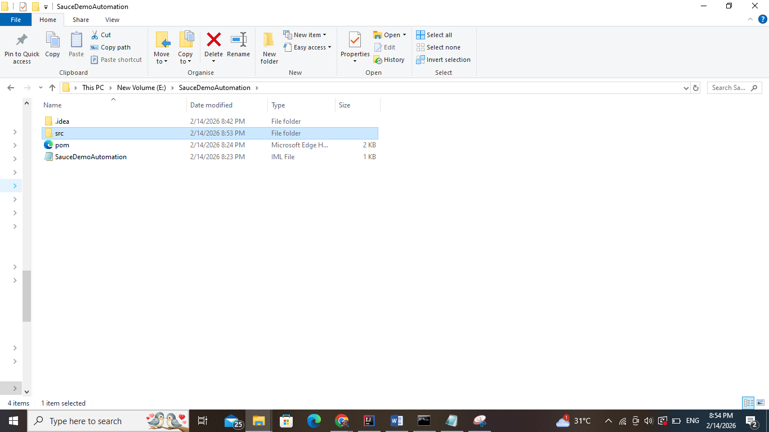

**BaseTest.java**

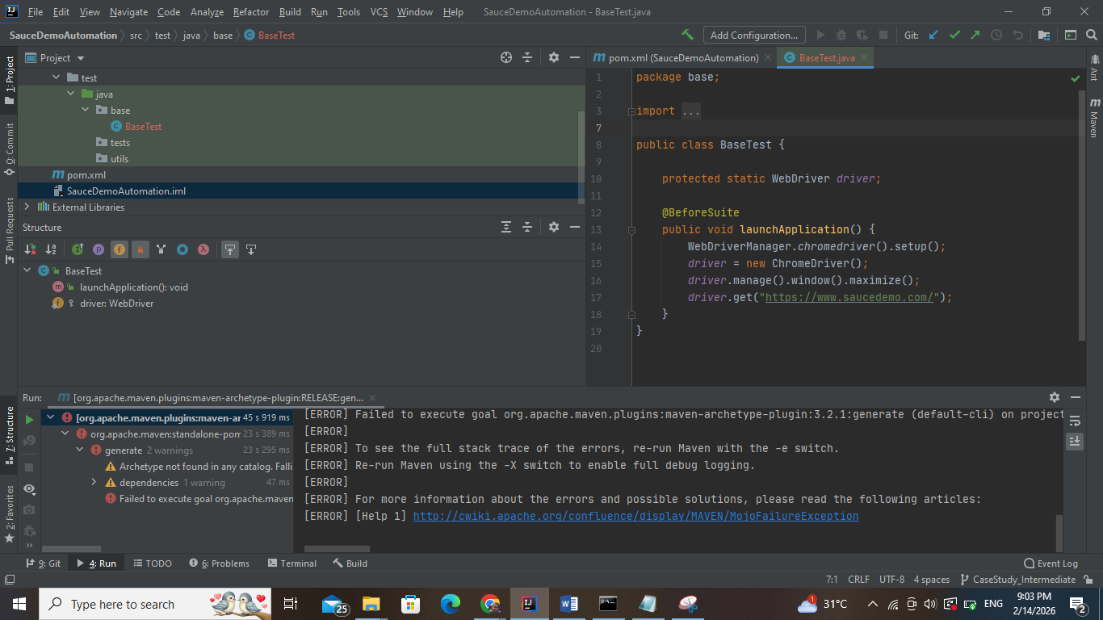

package base;  
  
import org.openqa.selenium.WebDriver;  
import org.openqa.selenium.chrome.ChromeDriver;  
import org.testng.annotations.BeforeSuite;  
import io.github.bonigarcia.wdm.WebDriverManager;  
  
public class BaseTest {  
  
 protected static WebDriver *driver*;  
  
 @BeforeSuite  
 public void launchApplication() {  
 WebDriverManager.*chromedriver*().setup();  
 *driver* = new ChromeDriver();  
 *driver*.manage().window().maximize();  
 *driver*.get("https://www.saucedemo.com/");  
 }  
}

### GenericMethods.java

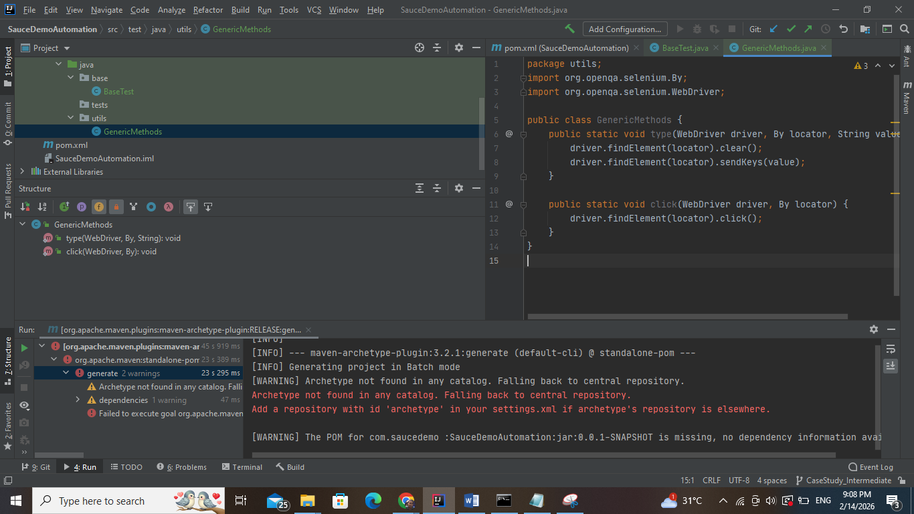

package utils;  
import org.openqa.selenium.By;  
import org.openqa.selenium.WebDriver;  
  
public class GenericMethods {  
 public static void type(WebDriver driver, By locator, String value) {  
 driver.findElement(locator).clear();  
 driver.findElement(locator).sendKeys(value);  
 }  
  
 public static void click(WebDriver driver, By locator) {  
 driver.findElement(locator).click();  
 }  
}

### ScreenshotUtil.java

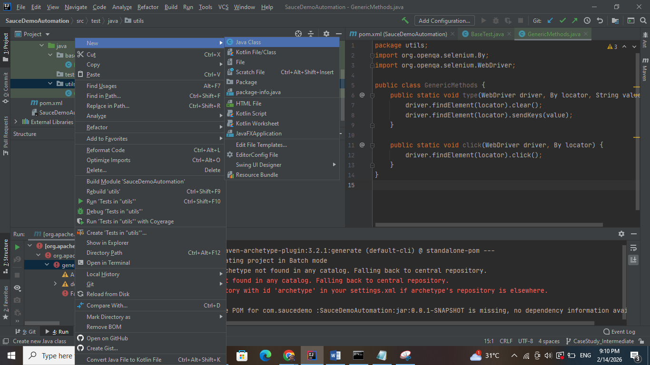

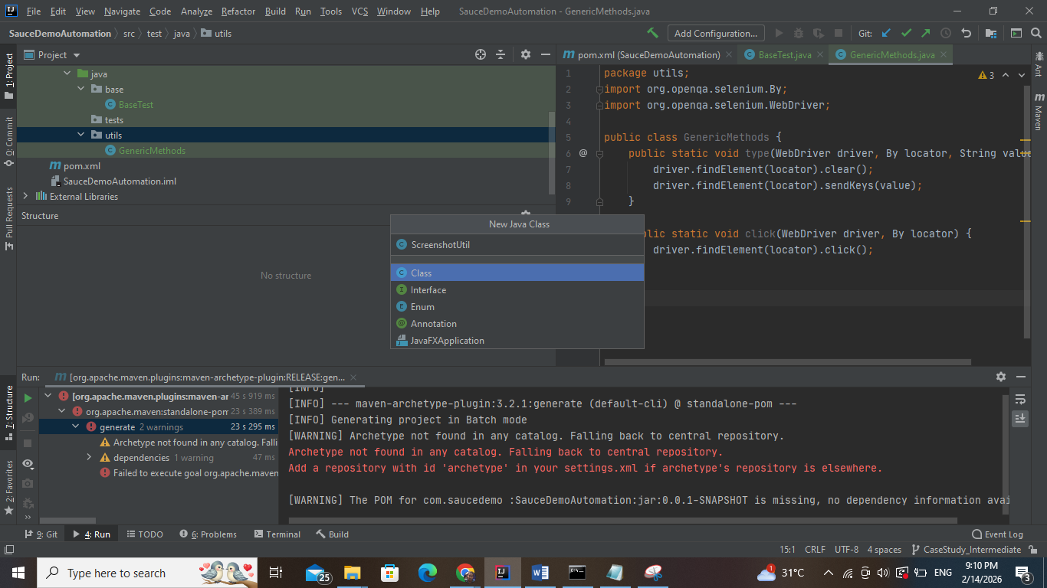

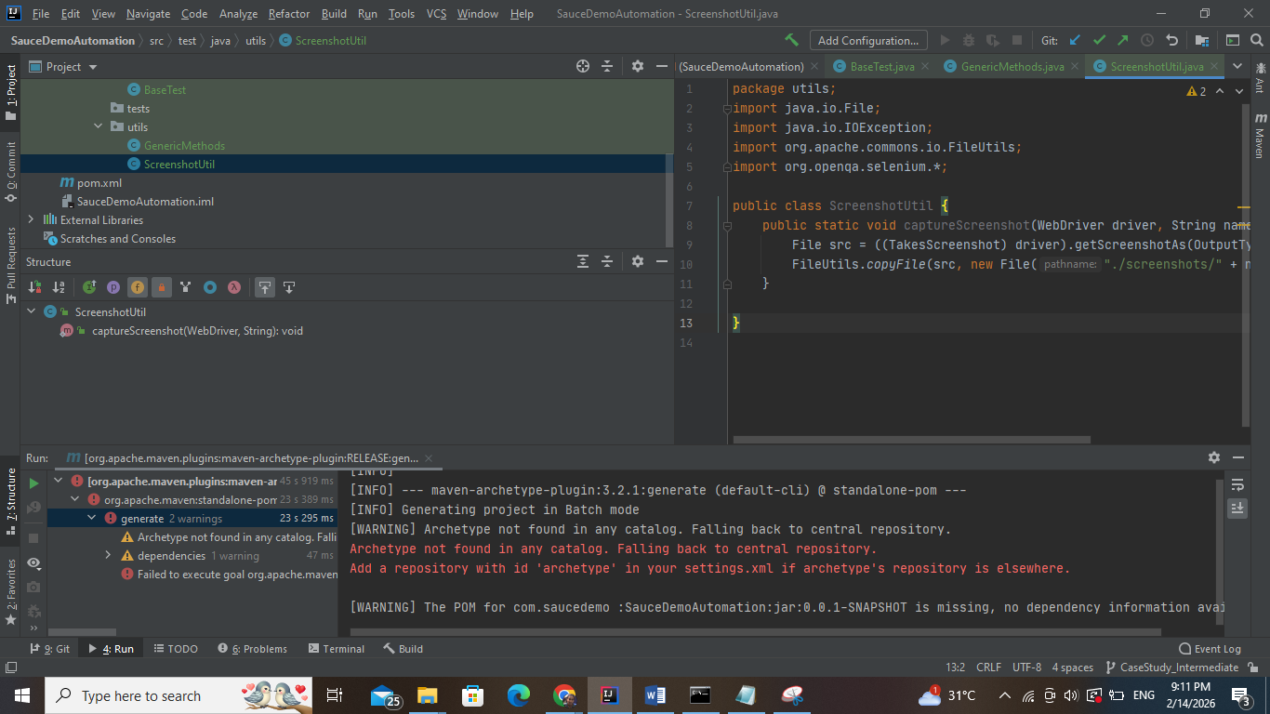

package utils;  
import java.io.File;  
import java.io.IOException;  
import org.apache.commons.io.FileUtils;  
import org.openqa.selenium.*;  
  
public class ScreenshotUtil {  
 public static void captureScreenshot(WebDriver driver, String name) throws IOException {  
 File src = ((TakesScreenshot) driver).getScreenshotAs(OutputType.*FILE*);  
 FileUtils.*copyFile*(src, new File("./screenshots/" + name + ".png"));  
 }  
  
}

Create TestNG Test Class

### LoginTest.java

### 

### 

### 

package tests;  
  
import base.BaseTest;  
import utils.GenericMethods;  
import utils.ScreenshotUtil;  
  
import org.openqa.selenium.By;  
import org.testng.Assert;  
import org.testng.annotations.Parameters;  
import org.testng.annotations.Test;  
  
public class LoginTest extends BaseTest {  
  
 @Test(priority = 1)  
 public void verifyTitle() {  
 Assert.*assertEquals*(*driver*.getTitle(), "Swag Labs");  
 }  
  
 @Test(priority = 2)  
 @Parameters({"username","password"})  
 public void validLogin(String username, String password) throws Exception {  
  
 GenericMethods.*type*(*driver*, By.*id*("user-name"), username);  
 GenericMethods.*type*(*driver*, By.*id*("password"), password);  
 GenericMethods.*click*(*driver*, By.*id*("login-button"));  
  
 Assert.*assertTrue*(*driver*.getTitle().contains("Swag Labs"));  
 ScreenshotUtil.*captureScreenshot*(*driver*, "ValidLogin");  
 }  
  
 @Test(priority = 3)  
 @Parameters({"invalidUser","invalidPwd"})  
 public void invalidLogin(String user, String pwd) throws Exception {  
  
 *driver*.navigate().refresh();  
  
 GenericMethods.*type*(*driver*, By.*id*("user-name"), user);  
 GenericMethods.*type*(*driver*, By.*id*("password"), pwd);  
 GenericMethods.*click*(*driver*, By.*id*("login-button"));  
  
 Assert.*assertTrue*(*driver*.getCurrentUrl().contains("saucedemo"));  
 ScreenshotUtil.*captureScreenshot*(*driver*, "InvalidLogin");  
 }  
}

Create testng.xml

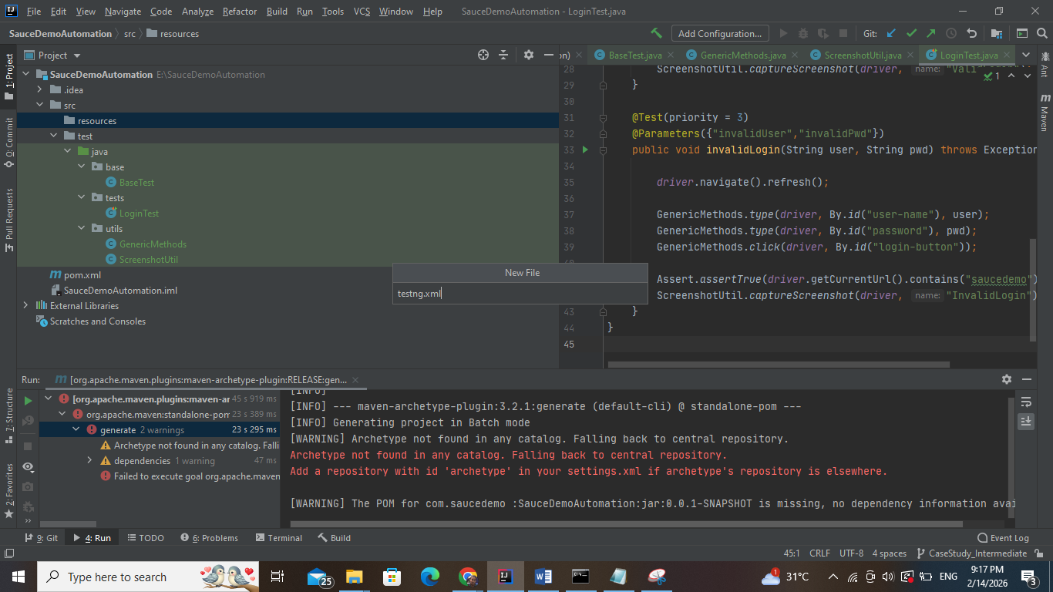

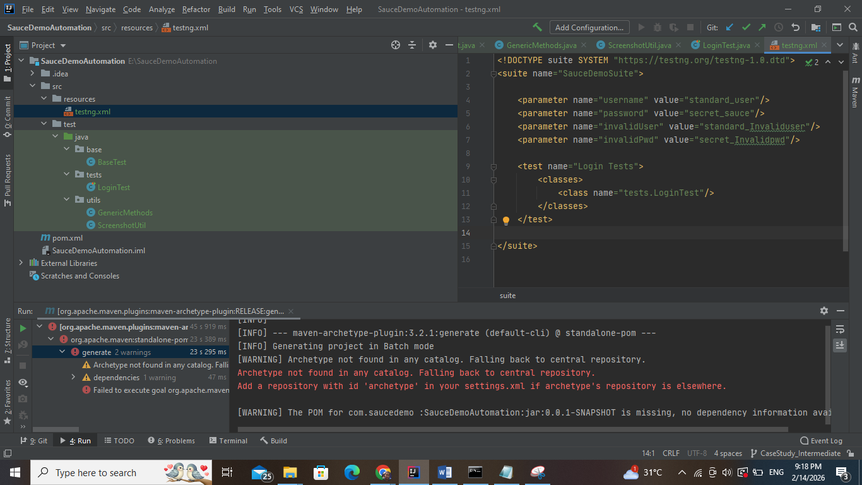

<!DOCTYPE suite SYSTEM "https://testng.org/testng-1.0.dtd">  
<suite name="SauceDemoSuite">  
  
 <parameter name="username" value="standard_user"/>  
 <parameter name="password" value="secret_sauce"/>  
 <parameter name="invalidUser" value="standard_Invaliduser"/>  
 <parameter name="invalidPwd" value="secret_Invalidpwd"/>  
  
 <test name="Login Tests">  
 <classes>  
 <class name="tests.LoginTest"/>  
 </classes>  
 </test>  
  
</suite>

Run Tests from TestNG.xml

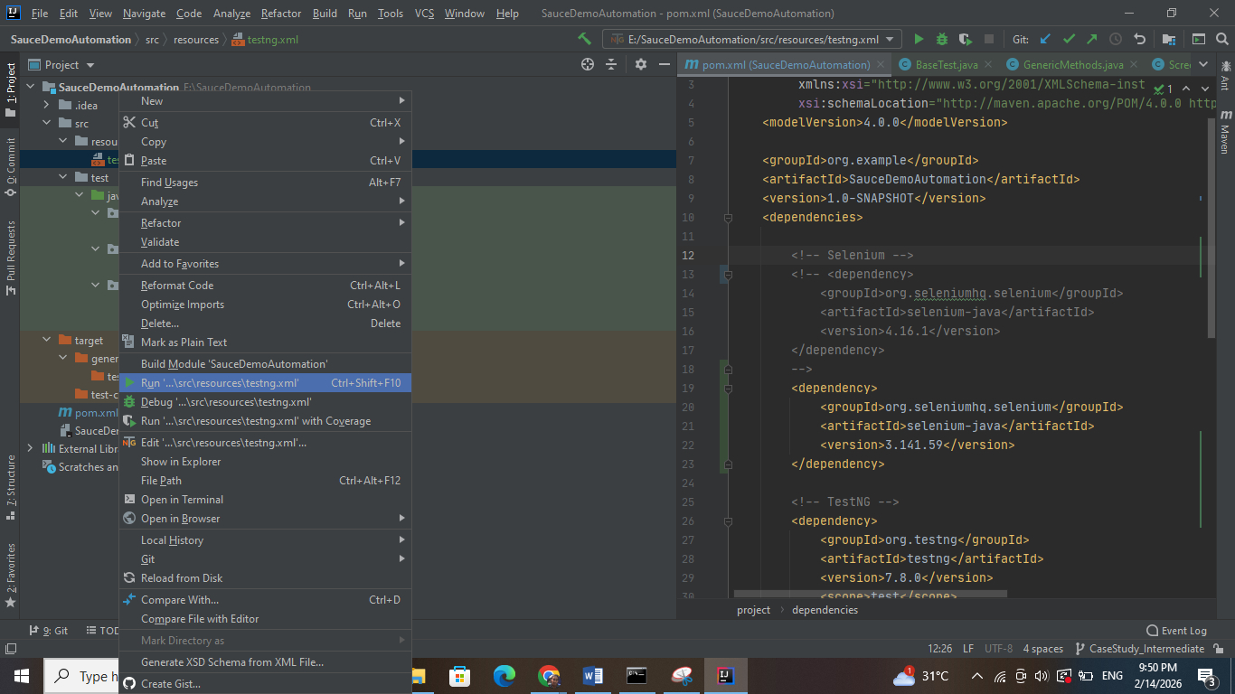

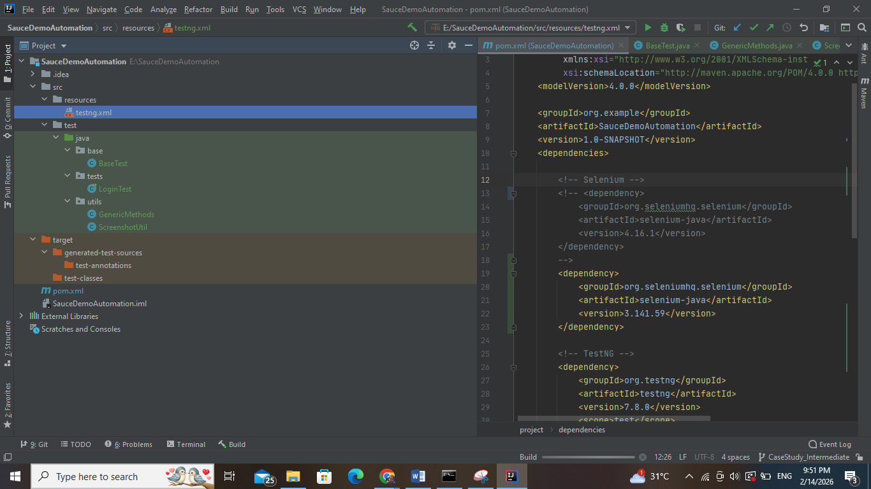

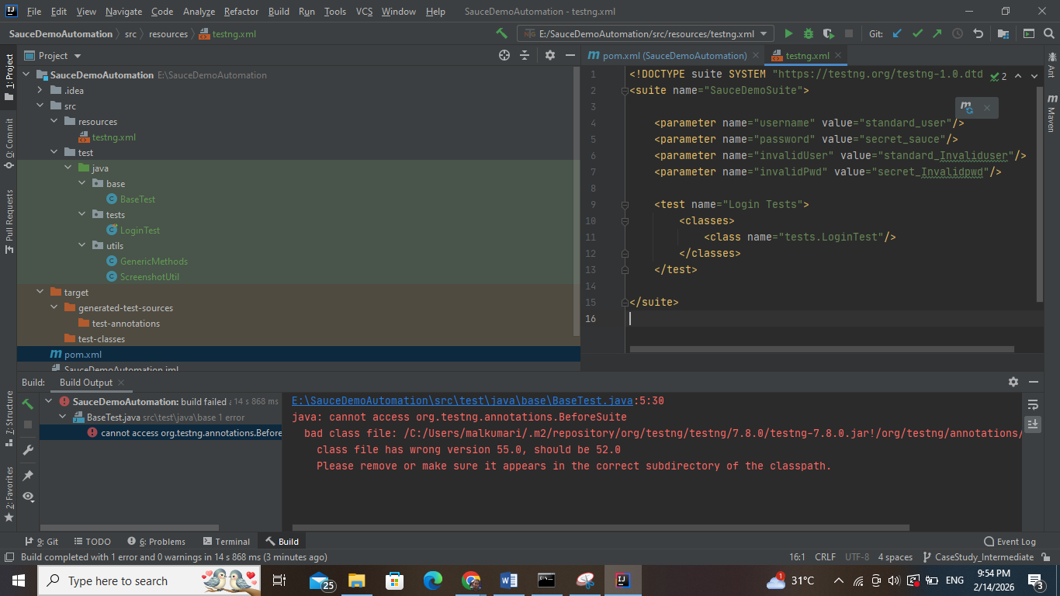

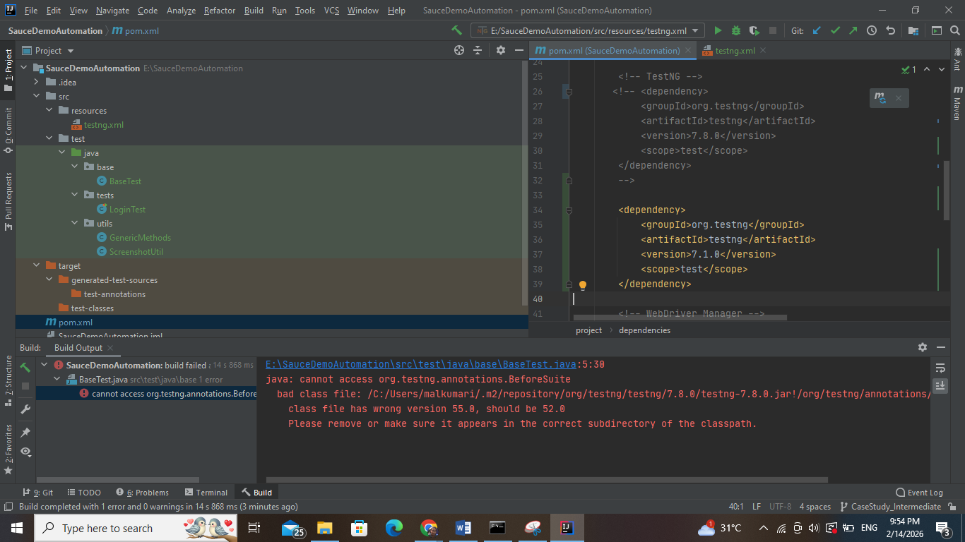

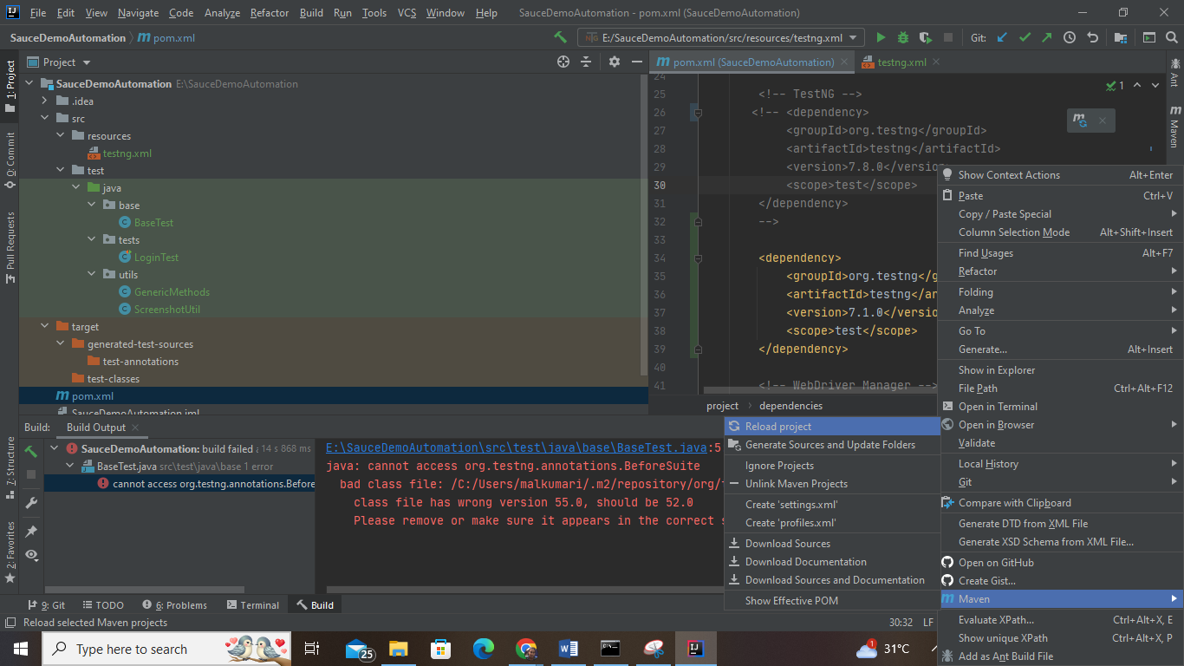

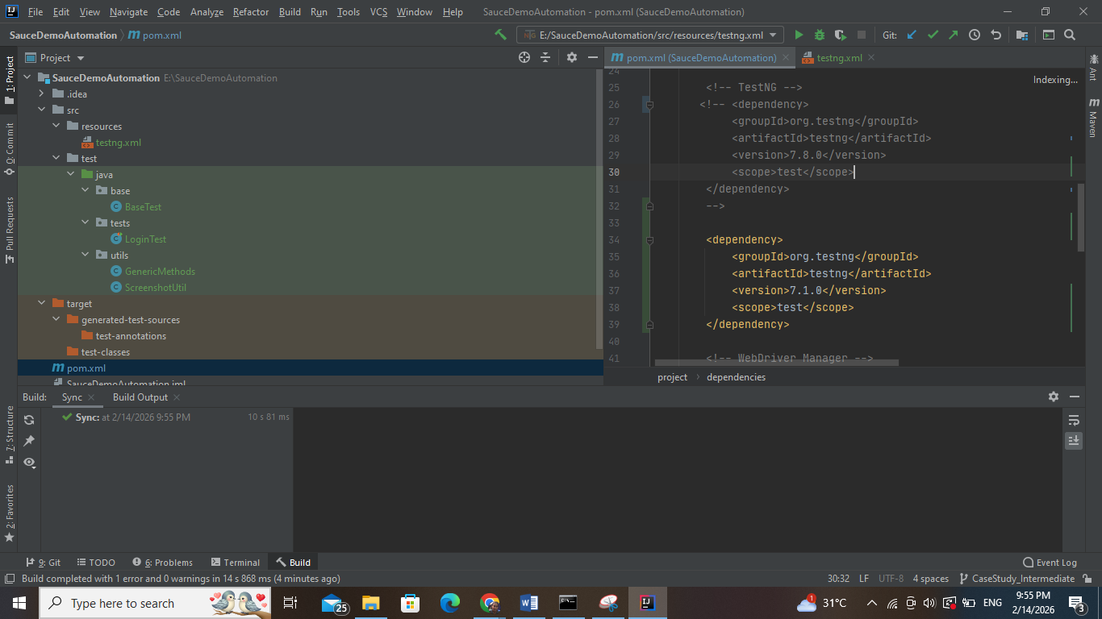

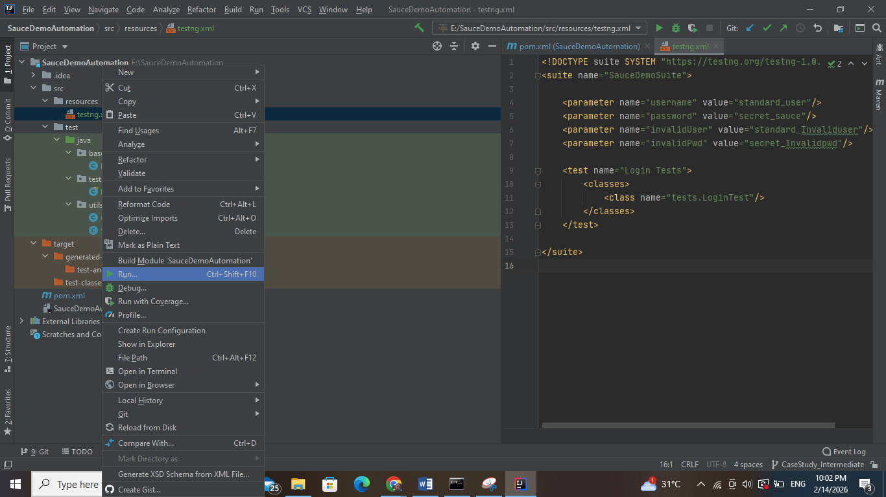

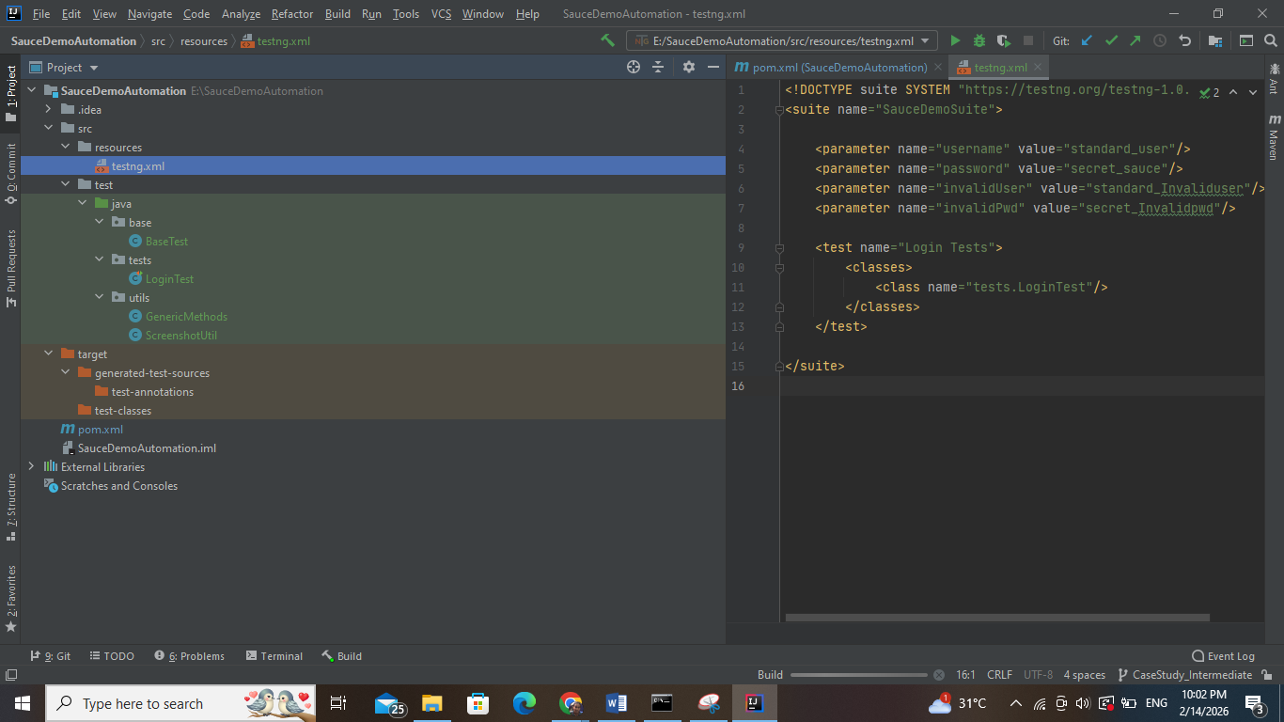

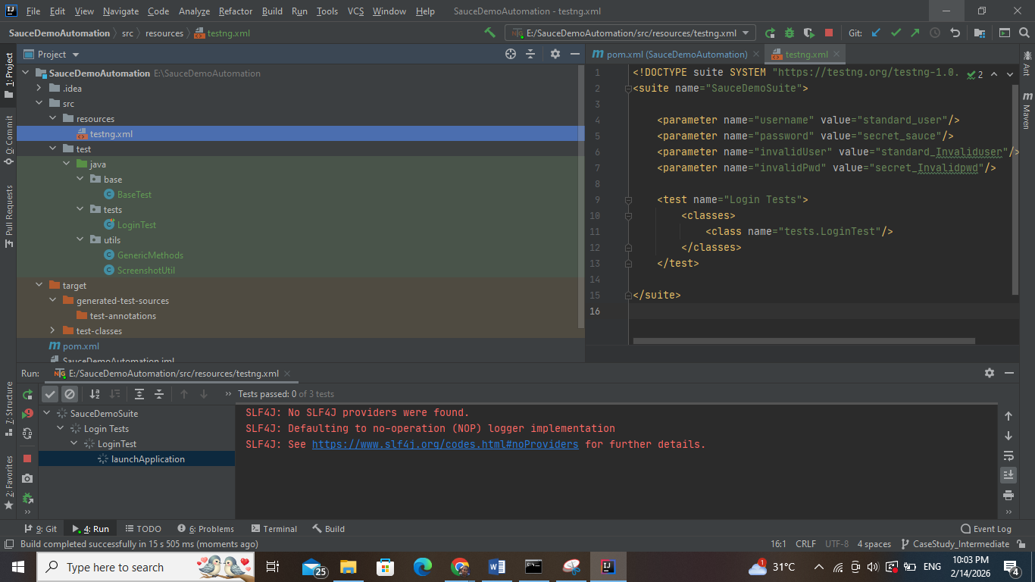

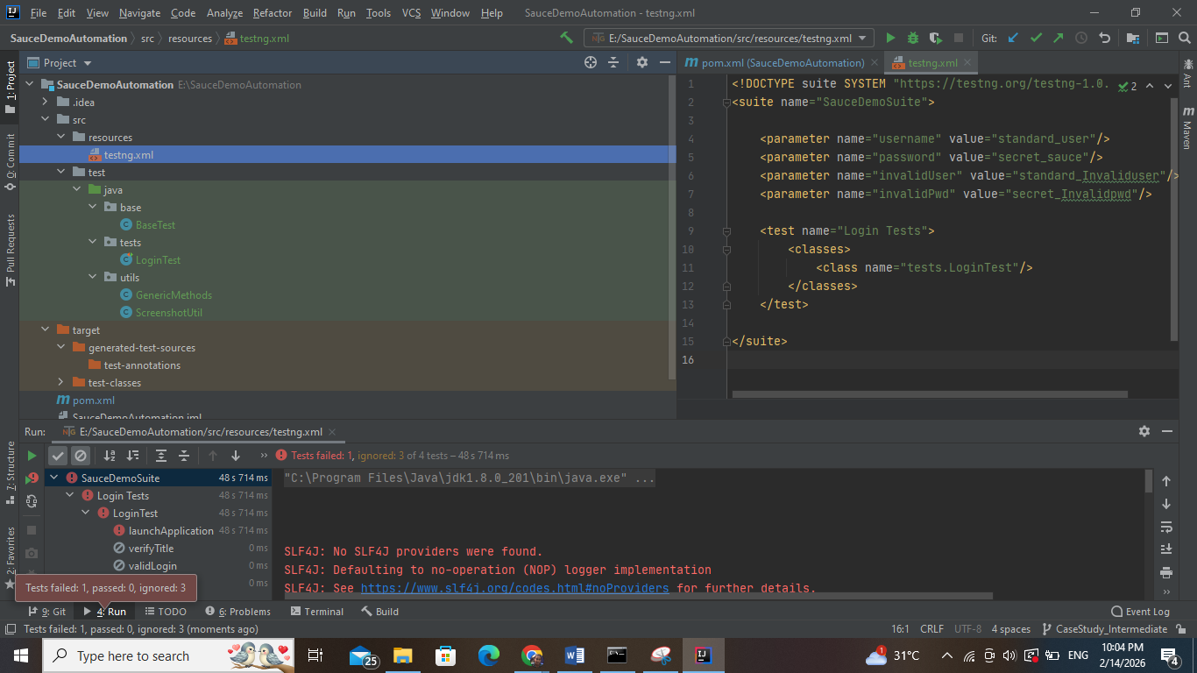

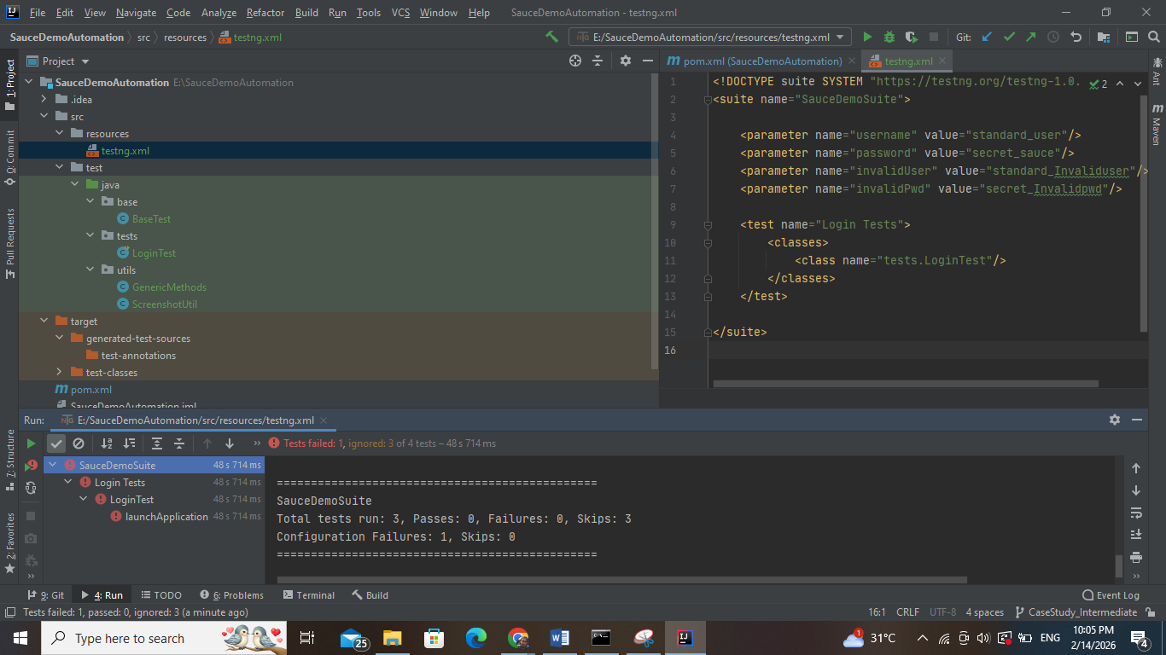

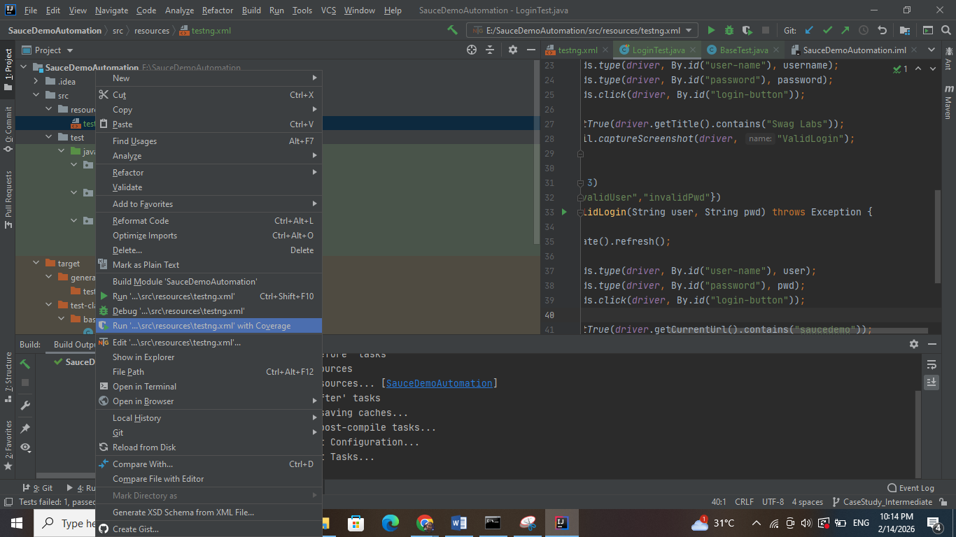

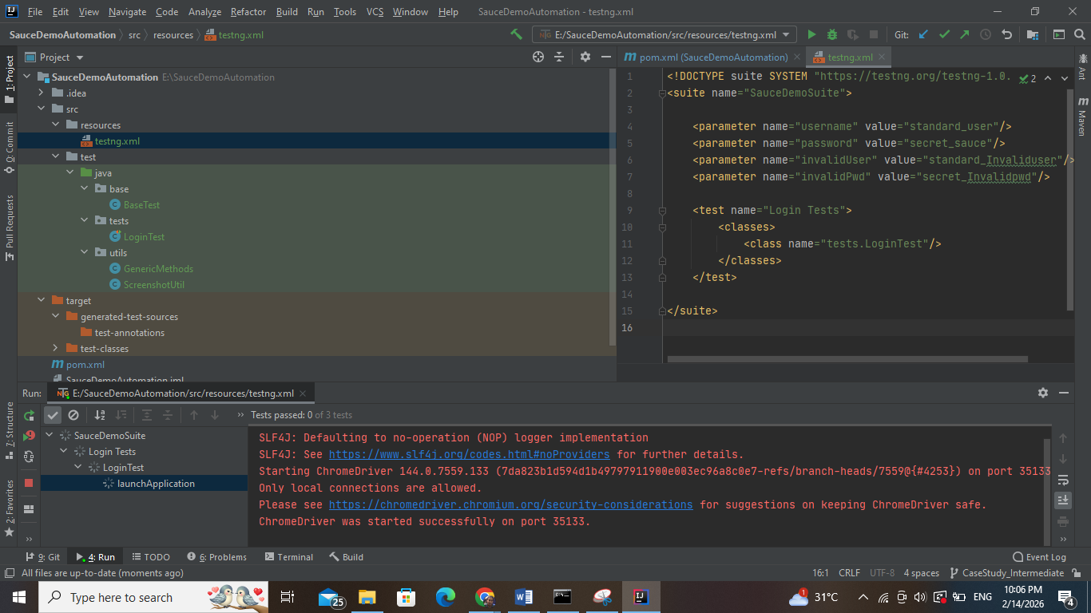

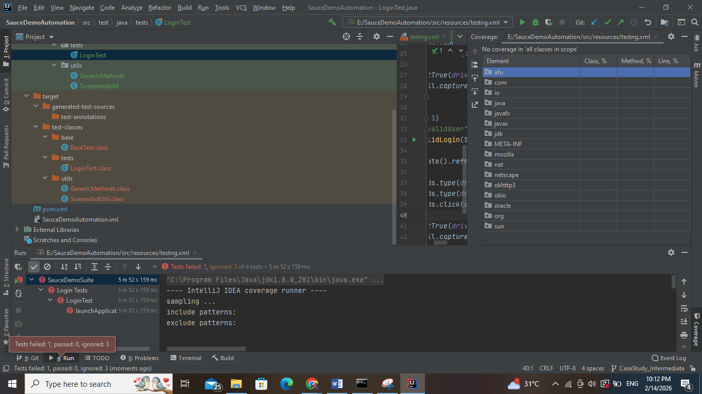

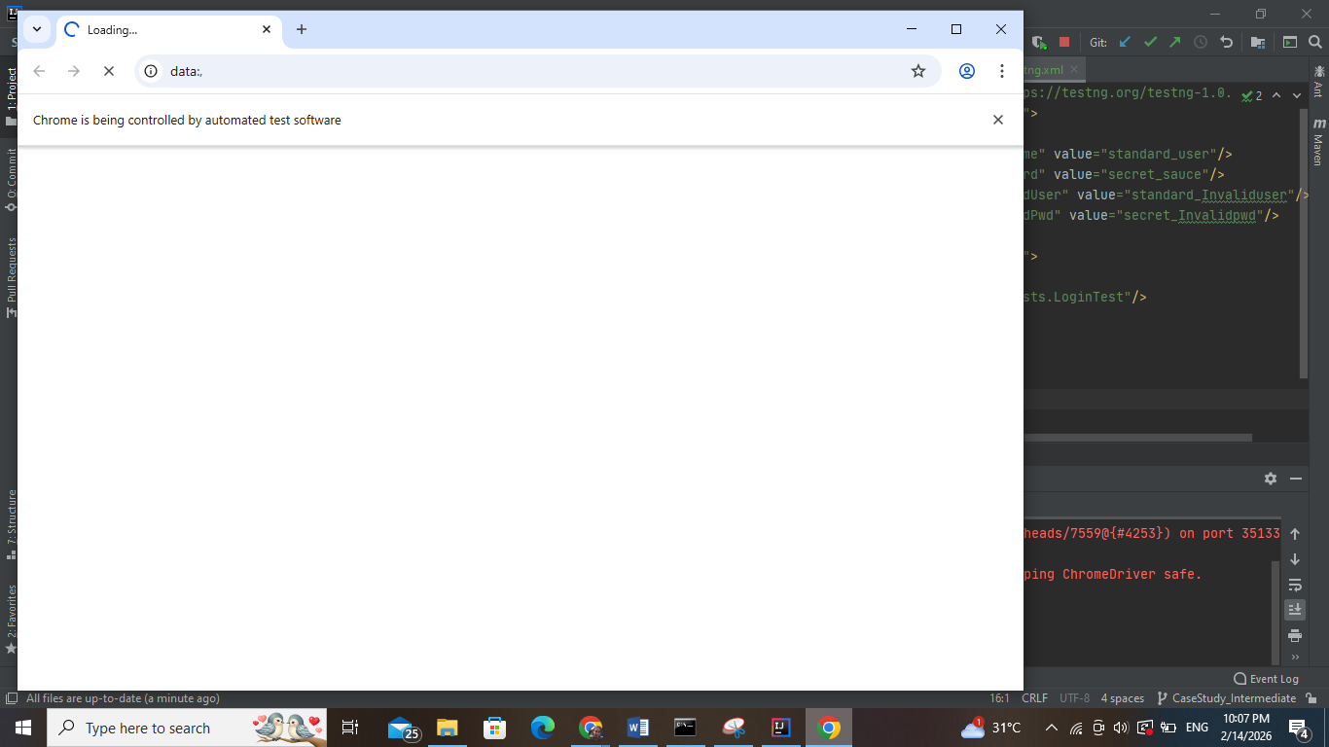

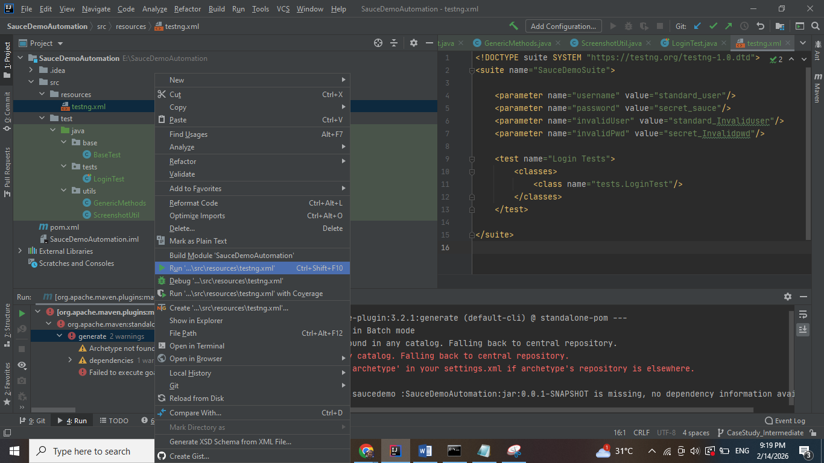

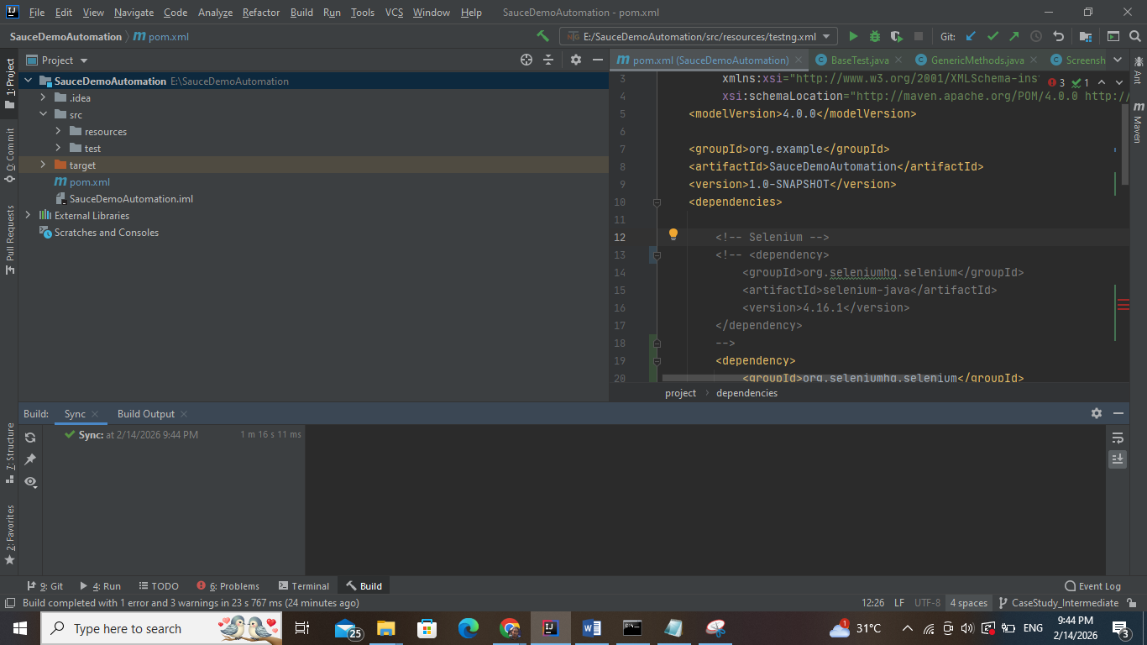

Commit the latest changes of the project to git

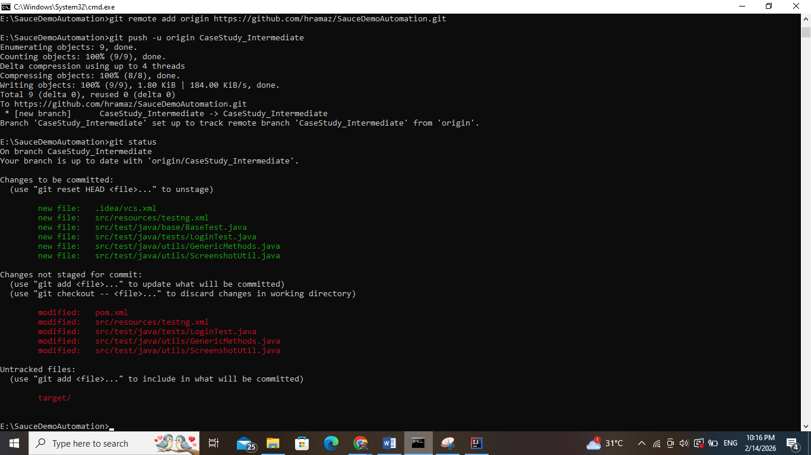

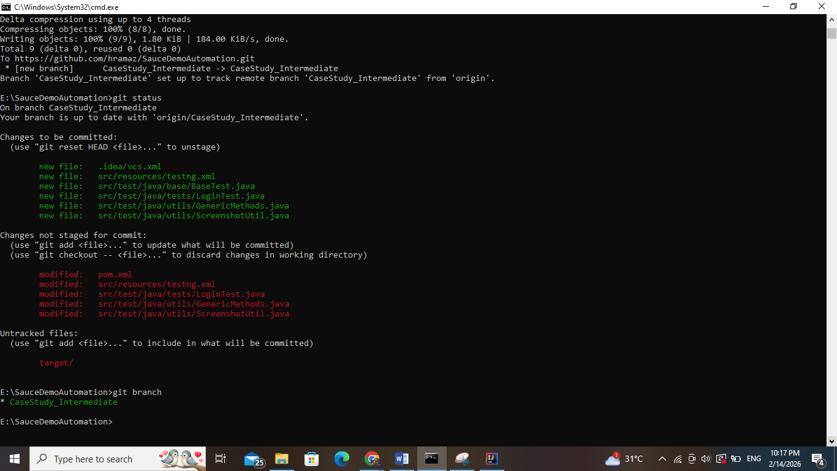

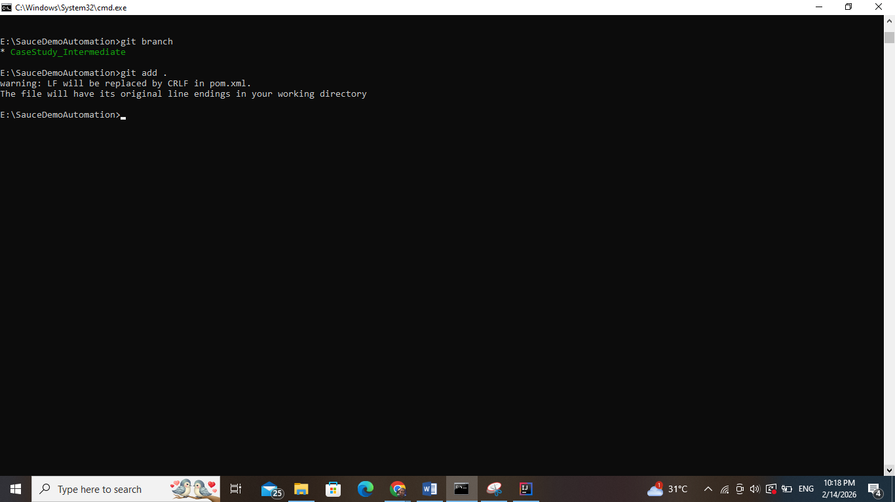

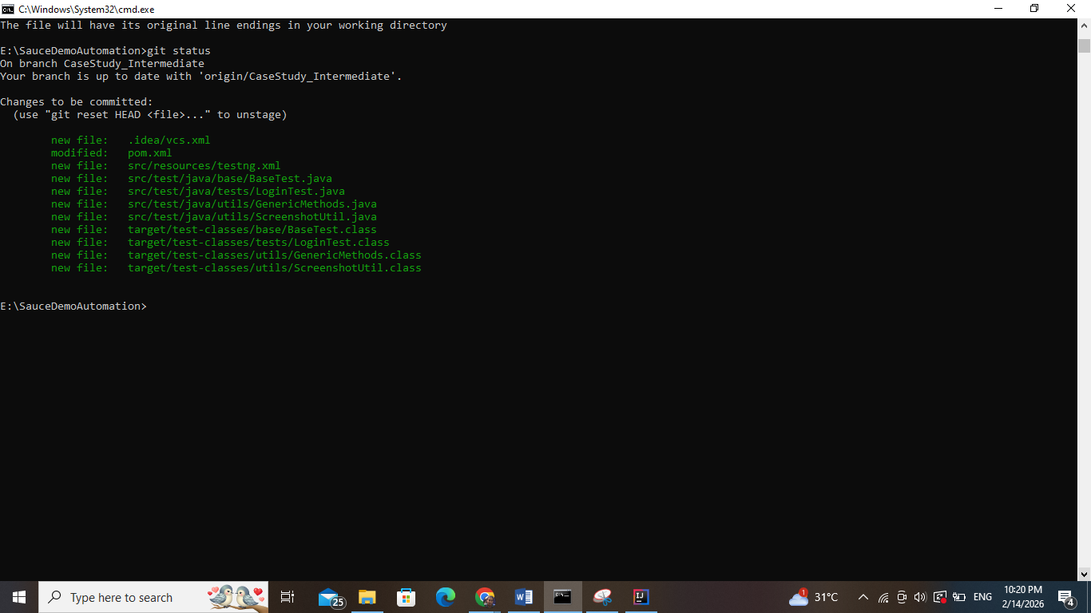

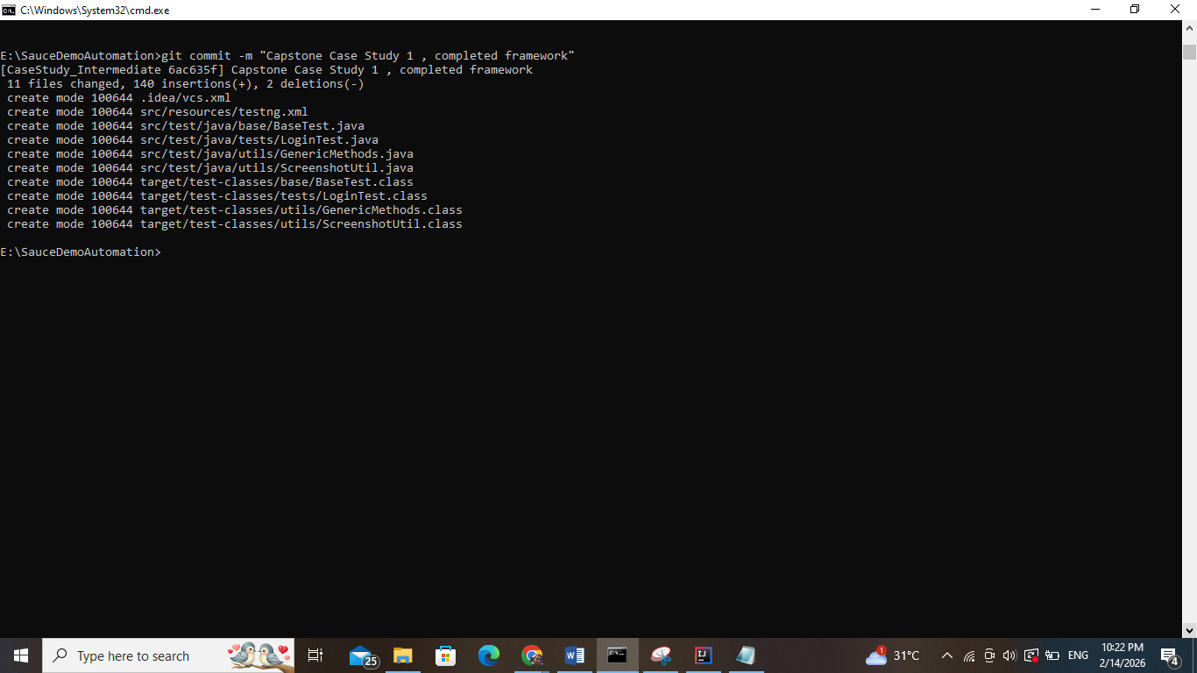

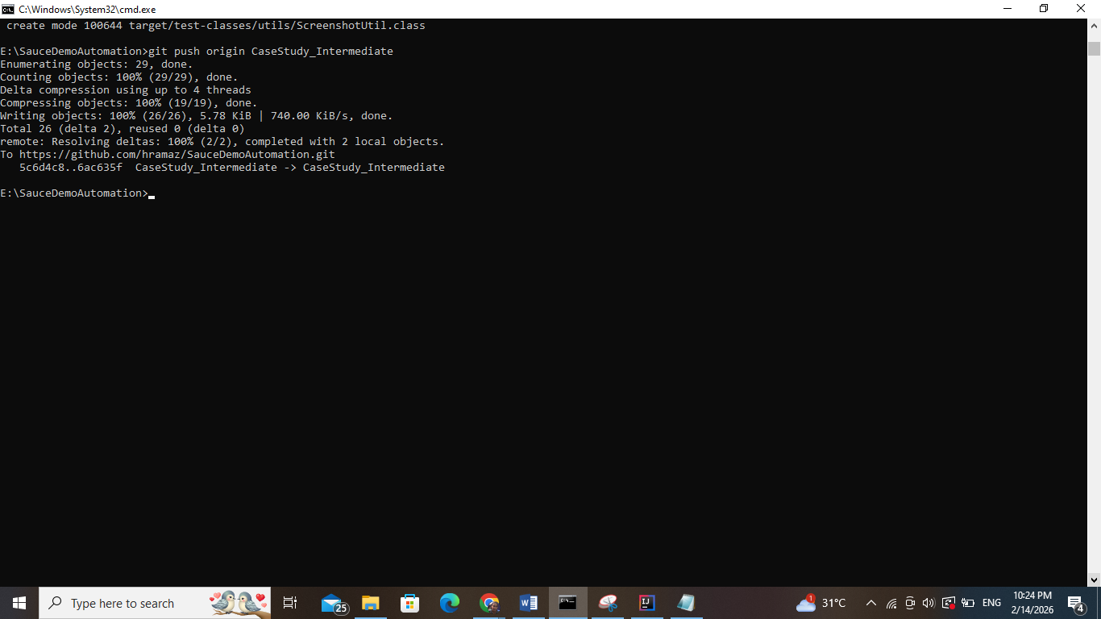

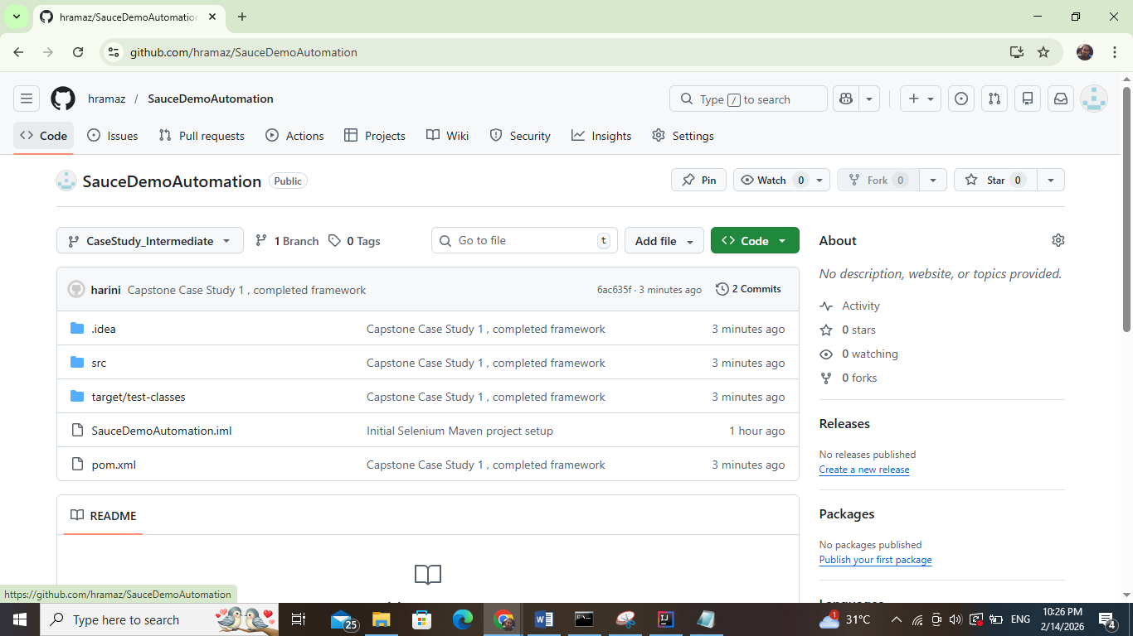

Repository Name: SauceDemoAutomation

Repository URL: <https://github.com/hramaz/SauceDemoAutomation/tree/CaseStudy_Intermediate>